Chapter 12, Solution 84.

We first find the magnitude of the various currents.

For the motor,
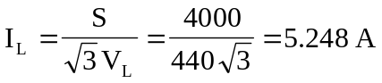

For the capacitor,
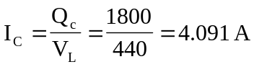

For the lighting,
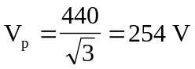

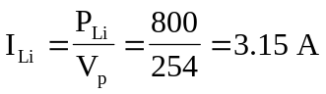

Consider the figure below.
-jX_{C}
a
I_{C}
I_{b}
+
V_{ab}
−
I_{c}
I_{a}
I₂
I₃
I₁
I_{Li}
b
c
n
I_{n}
R

If 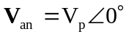, 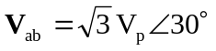
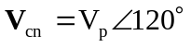

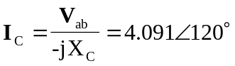

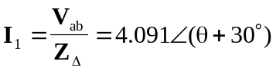
where 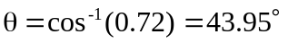

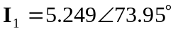

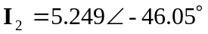

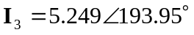

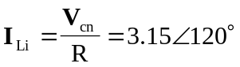

Thus,
